Circle Language Spec: Parameters

Parameter Order in a Diagram
The article Parameter Order introduced the concept of an ordered list of parameters. The diagramatic display of parameter order is still not final.

In a diagram the order of the parameters could be expressed just like the order of consecutive commands are ordered by next-command references. See Execution Control, Normal Execution Order. This display is yielded over to ordering objects, and ordering parameters as well.

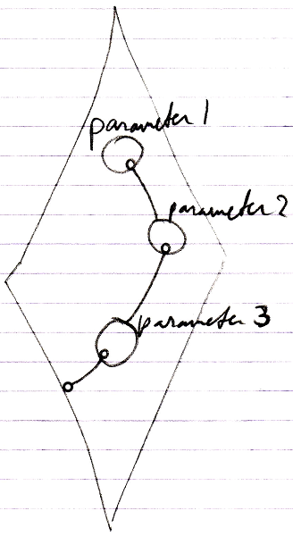

Perhaps the first item will also be denoted like this:

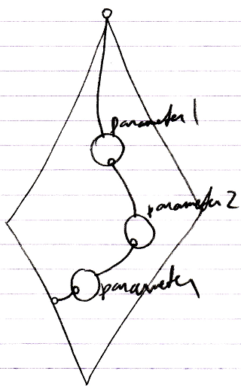

The eventual display is all up to the implementation of Object Order. That will determine the ways sorted objects are displayed. The ideas introduced here are preliminary. Eventually parameter order will comply to object order.

The objects may also be displayed clockwise:

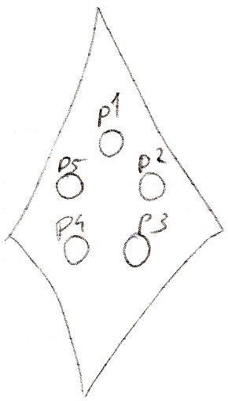

And possibly, when there are a lot of items in the collection, you may need scroll through them, because they can’t all be individually displayed:

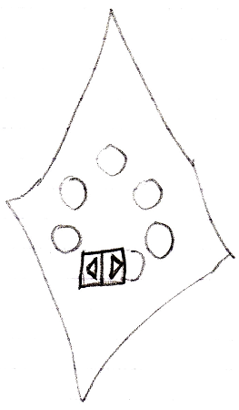

See also: Parameter Order

Author & Copyright: Jan-Joost van Zon Date: September 30, 2008 – September 30, 2008 Location: Oosterhout, The Netherlands Status: Finished

